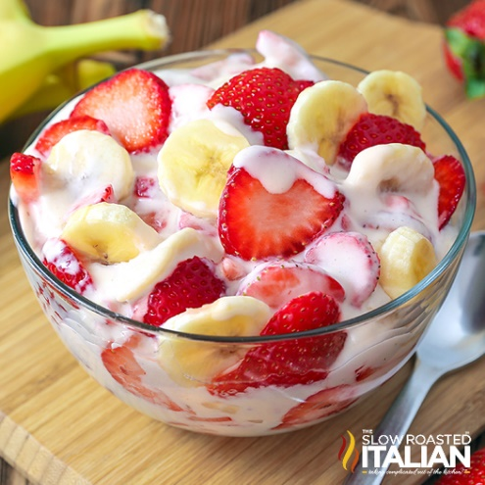
Strawberry Banana Cheesecake Salad
Prep time/Total time 15 min
16 Servings
Ingredients
8 oz package cream cheese, softened
3.4 oz package instant cheesecake pudding
1 cup French vanilla coffee creamer
2 lb strawberries
3 medium bananas
2 tbsp fresh lemon juice
Directions
- Hull and slice strawberries. Set aside.
- Microwave cream cheese for 20 seconds to soften.
- In a medium tall bowl, using an electric mixer, whip cream cheese until it becomes smooth. It may bind up in the beaters but continue as is and it will loosen up.
- Add the dry pudding mix. Beat about 2 minutes until well combined. If the mixture is too thick you can add a splash of the measured creamer to loosen it up.
- With the mixer running slowly, add creamer to the cream cheese approximately a tablespoon at a time (otherwise it will become lumpy). Mix until it becomes a smooth mixture and all the creamer has combined into the cream cheese. Continue to whip until smooth, light and fluffy, about 2 minutes.
- Cut bananas into coins. In a large bowl, combine sliced strawberries, bananas and lemon juice. Stir until all the fruit is coated with lemon juice. Add fruit to cheesecake mixture.
- Serve immediately or chill until ready to serve.

Notes
To make ahead of time, prepare cheesecake mixture and refrigerate in a bowl. Mix all the fruit in a large bowl and refrigerate. Before serving, drain any excess liquid from the fruit and then fold the cheesecake filling into the fruit.
You can substitute 1 cup heavy cream, ¼ cup powdered sugar and 2 teaspoons of vanilla extract for creamer.

